AGENDA & BIOGRAPHIES
AFEW Regional Autumn School
29-31 Oct. 2019
Bishkek, Kyrgyzstan

AGENDA REGIONAL AUTUMN SCHOOL 2019- BISHKEK, KYRGYZSTAN
Tuesday 29 Oct: updates on country and regional level (big room)
8.30-9.00 Registration
9:00-9.30 Welcome
9:30-10:30 Session 1: Bridging the gaps country updates from Georgia, Kyrgyzstan, Ukraine and Tajikistan
10:30-11:00 Coffee break
11:00-12:00 Session 2: Updates from the Eastern Europe and Central Asia region
12:00 Announcement by Jake Rashbass (EJAF)
12.00-13.00 Lunch
13.00-14.30 World Café- dreams and challenges into action
13:05-13:40 Round 1
13:50.14:30 Round 2
- Kazakhstan and Uzbekistan (medium conference room)
- Georgia and Ukraine (small conference room)
- Kyrgyzstan, Tajikistan and Russia (big conference room)
14:30-15:00 Coffee break
15.00-16.00 World Café- wrap up
16:30 Leaving with the bus for dinner and social event

Wednesday 30 Oct: stimulant use and chemsex (big room)

9.00-9.30 Welcome by Yuri de Boer (AFEW International, NL)
9.30-10.00 Presentation Benjamin Collins (International HIV Partnership, UK)
“People, People, Where’s the Hope?” Responding to problematic chemsex
10.00-10.15 Video message from Esther Croes (Trimbos Institute, the Netherlands)
10.15-10.30 Questions and discussion
10:30-11:00 Coffee break
11.00-11.30 Presentation by Monty Moncrieff (London Friend, UK)
“Community engagement and harm reduction: Lessons from London”
11.30-12.00 Presentation by Nikolay Lyuchenkov (Freelance activist, Russia)
“Chemsex in EECA: Messages from Moscow”
12:00-12:30 Questions and discussion
12:30-13:30 Lunch
13:30-15:00 Case studies:
- Ben Collins: "Do we have to respond to every crisis?”
- Monty Moncrieff: Chemsex, Community and Care – More than just sex and drugs
- Nikolay Lyuchenkov (session in Russian language) – trends and responses to chemsex in Russia and the EECA Region
15:00-15:30 Coffee break
15:30-16:00 Reporting back on case studies
16:00-16:30 Open floor: questions from public
16:30-17:00 Wrap up: panel discussion with speakers
18:30-20:00 Dinner served at the hotel
Thursday 31 Oct:
Workshops on migration, rehabilitation and financial sustainability
Session 1: Sustainable funding (big room)
9.00-9.30 Welcome and introduction of participants
9.30-10.30 Analysis of NGOs funding situation in EECA region by Zhenya Alexeeva (FOCUS-media, Russia)
10.30-11:00 Coffee break
11.00-12.00 Analysis of NGOs funding situation in EECA region by Zhenya Alexeeva
12.00-12.30 Social entrepreneurship. Case study from Kyrgyzstan
by Elena Zhirnova (AFEW Kyrgyzstan)
12.30- 13.30 Lunch
13:30-14:30 Social entrepreneurship. Case study from Kyrgyzstan by Elena
14.30-15.00 Auditing Resources to Launch a Business Model: recommendations on how to implement business ideas by Fatima Yakupbaeva (Precedent, Kyrgyzstan)
15:00-15:30 Coffee: opportunity to buy a book from Fatima Yakupbaeva
15:30-16.30 Auditing Resources to Launch a Business Model: recommendations on how to implement business ideas
16.30-17.00 Wrap up and closure
17.00-17:30 Back to plenary: evaluation and certification
18:30-20:00 Dinner served at the hotel

Session 2: Key population labour migration to Russia (medium conference room)
9.00-9.30 Welcome and introduction of participants
9.30-10.30 Presentation by Rukshona Qurbonova (IOM Tajikistan) about labour
migration in Central Asia, their role and a video
10.30-11.00 Coffee break
11.00-11.40 Presentation by Zulaika Esentaeva (IOM Kyrgyzstan) on service-delivery by
IOM Kyrgyzstan for vulnerable migrants
11.40- 12:10 Presentation by Lyudmila Vins (LUNA, Russia) on results of a research project in Ekaterinburg
12:10- 12:30 Presentation by Lyudmila Vins on harm reduction
12.30-13.30 Lunch
13.30-13:40 Time for questions
13:40- 14.00 Introduction to the interactive exercise
by Judith Kreukels (AFEW International)
14.00- 15:00 Group work
15.00-15.30 Coffee: opportunity to buy a book from Fatima Yakupbaeva
15.30- 17.00 Feeding back to the plenary
17.00-17:30 Back to plenary: evaluation and certification
18:30-20:00 Dinner served at the hotel

Session 3: Rehabilitation (small conference room)

09:00 – 09:15 Opening and introduction of participants
09:15 – 10:00 Introduction of the goals and expected results of informational campaigns in ……………………. each country
10:00 – 10:30 Analysis of target audiences: values, interests, fears and other characteristics that can influence informational campaigns (Part 1).
10:30 – 11:00 Coffee break
11:00 – 11:30 Analysis of target audiences: values, interests, fears and other characteristics that can influence informational campaigns (Part 2).
11:30 – 12:30 Expected results: how we can measure our success
12:30 – 13:30 Lunch
13:30 – 15:00 Development of the key messages
15:00 – 15:30 Coffee break: opportunity to buy a book from Fatima Yakupbaeva
15:30 – 17:00 Instruments and communication channels
17:00 – 17:30 Back to plenary: evaluation and certification
18:30-20:00 Dinner served at the hotel

BIOGRAPHIES
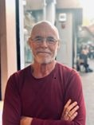
Ben Collins is the director of International HIV Partnerships (IHP), which partners with medical and community activists across WHO Europe and the Middle East for successful responses to HIV and viral hepatitis. He’s also a convenor of ReShape, a London-based think tank to reshape responses to HIV, viral hepatitis and related sexual and mental health concerns. IHP is the secretariat for the European Chemsex Forum. Ben is chair of the European Testing Week work group, and serves on advisory committees for INTEGRATE Joint Action, Women Against Viruses in Europe and the International Committee on the Rights of Sex Workers in Europe. He is a member of EATG, and co-chair of its Development and Membership Advisory Group. Ben has been HIV+ since 1981, undetectable since 1998, and lives in London.
Contact details: bc@ihp.hiv

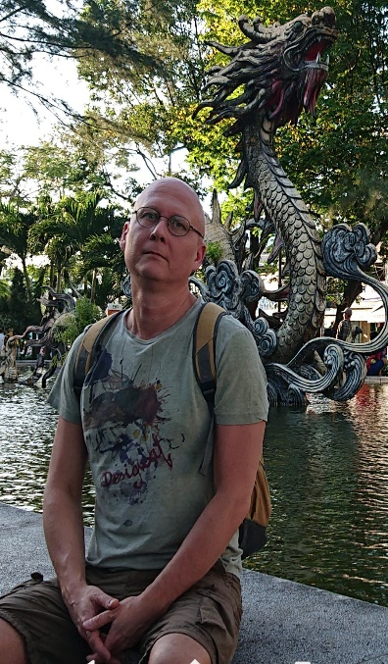
Denis Kamaldinov, (MD/ Ph.D.) has a higher medical education in social programs for the prevention of HIV, drug addiction and STIs and has been working since 1993. He worked as a psychotherapist at the Juventus Consultative and Diagnostic Center for Children and Adolescents (a youth-friendly clinic), taught at the Department of Psychiatry, Psychotherapy and Narcology, Department of Advanced Medical Studies, Novosibirsk Medical University. His PhD thesis was defended in 2002 and is devoted to the formation of identity in the use of opiates. He is one of the founders in 1998 of the Novosibirsk NGO "Humanitarian Project”, at which he is currently still working. The NGO "Humanitarian Project" is one of the leading organizations in Russia at present. The organization implements HIV prevention programs for key populations in the Novosibirsk Region, and runs a federal methodological center supported by the local Ministry of Health, the Russian Presidential Grants Fund, the Elton John AIDS Foundation, and others. Denis worked in Russia and in the EECA region as a consultant in HIV and drug prevention programs, for UN agencies (UNICEF, WHO, UNFPA, UNAIDS) and EU programs. Currently, he works as a facilitator, trainer and consultant on the development of NPOs, strategic planning, monitoring and evaluation of projects.
Contact details: dkamaldinov@yahoo.com

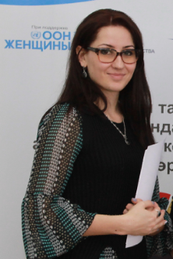
Elena Zhirnova is the manager of the project "Our Choice: Empowering Vulnerable Women in Kyrgyzstan" in AFEW Kyrgyzstan since 2017. This project aims to support, train and promote the rights of women from key populations.
In 2012, she received a diploma with honors in the specialty "World Economy". In 2013, she entered a master's degree program at Bordeaux IV-Montesquieu University in France in the direction of "Economic Development of the Third World". Contact details: elena.zhirnova@afew.kg

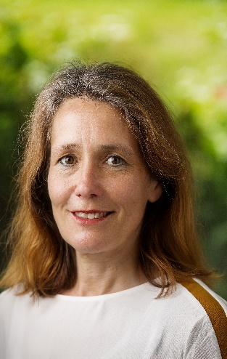
Esther Croes (MD PhD) is working as a senior research associate at the Trimbos Institute in the Netherlands, the national institute for mental health and addiction, for more than 12 years. Her expertise is in the physical consequences of drug use. She is the Drug Related Infectious Disease (DRID) expert of the Dutch Focal Point for the European Monitoring Centre for Drugs and Drugs Addiction (EMCDDA) and has been the project leader of many (implementation) studies on hepatitis C in drug users. Esther co-chairs the chemsex sessions at the yearly DRID expert meetings of the EMCCDA. Esther Croes is the project leader of the Monitor on Drug-related emergencies, which collects standardised information on drug-related health emergencies in emergency departments (ED’s), ambulance services, forensic doctors and first aid posts at large events since 2009. The data collected in these ten years covers over 45,000 patients, using a wide variety of (illegal) drugs. Finally, she is a member of the chemsex health providers network in Amsterdam, that tries to increase knowledge on specific chemsex issues. As part of that, she contributed to the development of a chemsex research agenda. In an effort to save the planet, she will not fly to this meeting but give this presentation from a distance. Contact details: ecroes@trimbos.nl

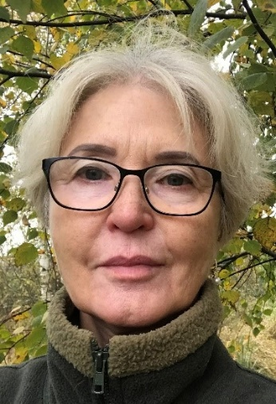
Evgeniya Alekseeva, PhD of medical sciences, is the Director of the Fund for social development and health protection "FOCUS-MEDIA". She is also Dance4Life's regional representative for Eastern Europe and Central Asia. Since 1986, Evgeniya Alekseeva has worked to achieve democratic change in society and founded several non-profit organizations. For more than 20 years, FOCUS-MEDIA has been implementing social projects in the field of prevention of HIV and sexually transmitted infections and employment of young people, as well as development of the non-profit sector and civil society in Russia. The Dance4Life project, which has been implemented by the Fund since 2005, is almost the only project in Russia aimed at preserving the health and personal development of young people.
Evgeniya Alekseeva is a member of the Board of Trusteeship in the social sphere under the Government of the Russian Federation, the Coordination Council on HIV/AIDS of the Ministry of Health of the Russian Federation, an expert of the Public Chamber of the Russian Federation.
Contact details: zhenya@dance4life.com, zhenya_alexeeva@focus-media.ru

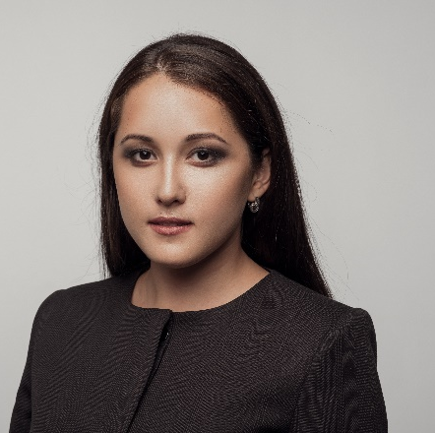
Fatima Yakupbayeva is an attorney, corporate lawyer, arbitrator and mediator of the International Court of Arbitration at the Chamber of Commerce and Industry of the Kyrgyz Republic. She is a co-founder of the law firm PRECEDENT. Fatima has conducted more than 300 trainings for lawyers, journalists and accountants. In 2018, she published a book "From Grant to Business Project", where she described 30 business models for NGOs that can help them become more financially sustainable by implementing inexpensive business projects.
Contact details: fatima.yakupbaeva@gmail.com


Lyudmila Vins is Project Manager of the LUNA Social Assistance Center. She is an ENPUD human rights specialist. Lyudmila has been living with HIV+ status since 2001. Since August 2009, she has been a member of the substitution therapy advocacy group in the Russian Federation. She also manages PWUD's access to legal aid projects "Street Lawyers". Through the work of a team of street lawyers, detailed materials were collected on how drug trafficking law and practice in Russia contributes to violations of the UN Convention against Torture. These materials were presented as a shadow report to the UN Committee against Torture in 2011. She also coordinates projects to protect the rights of women who use drugs, including survivors of domestic violence and police violence. Lyudmila also participates as a defender in court cases in which PWUD are accused of drug trafficking and as a representative of the PWUD community in civil and legal disputes to restore the rights of PWUD.
Contact details: pin.ekb@yandex.ru
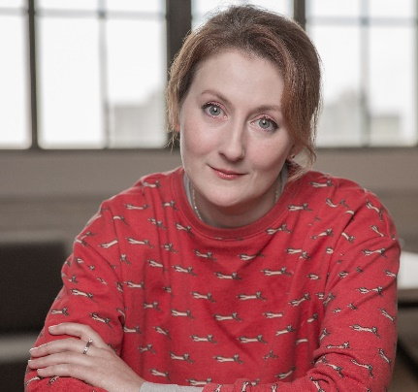
Marina Govorukhina is a specialist on strategic communications and branding. She works in business world and non-profit organizations field for 9 years. Marina is the Founder of the Piranha Club, a PR club of non-profit organizations. She is also the author of the books "Communications in Public Organizations", "Strategic Communications in Public Organizations". Marina was awarded with the “Best coach” title of Ukraine in 2018 according to the Marketplace platform.
Contact details: nerd.marina@gmail.com

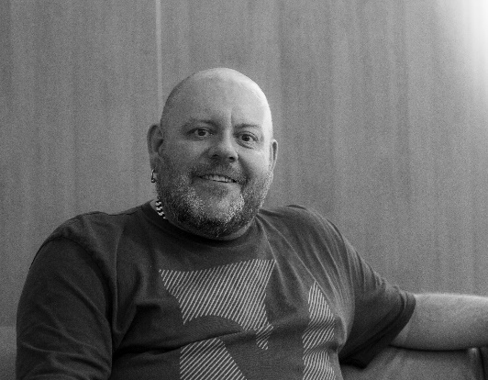
Monty Moncrieff MBE is the Chief Executive of London Friend, a charity working to promote the health and well-being of lesbian, gay, bisexual and trans (LGBT) people. London Friend is the oldest LGBT charity in the UK, providing support, including coming out groups and counselling, since 1972. The charity manages Antidote, a specialist LGBT drug and alcohol service, which was the first in the UK to observe the rise of chemsex amongst gay and bisexual men, and has developed innovative responses to changing service user need, taking an integrated approach to substance misuse, sexual and mental health. Their work in this field won a GSK IMPACT Award in 2016, and London Friend’s 120-strong volunteers won the Queen’s Award for Voluntary Service. Prior to London Friend Monty has worked and volunteer in the LGBT and substance misuse sectors for over 20 years, including managing a national programme of LGBT equality for the Department of Health. He has been listed in the Independ on Sunday’s Rainbow List of influential LGBT people three times. In 2018 he was awarded an MBE for Services to LGBT Equality. Outside of work he’s mildly obsessed with the Eurovision Song Contest.
Contact details: monty@londonfriend.org.uk


Nikolay Lunchenkov currently works as an infectious diseases doctor and treats patients with various infectious diseases and provides advice on sexual health. He realized he wanted to devote his life not only to fighting infectious diseases but also improving the healthcare system, ensuring it is providing quality healthcare to anyone who needs it regardless of immigration or social status, citizenship, nationality, gender or sexual orientation. In the past two years he works with several non-profit organisations where he manages and coordinates health projects such as HIV testing and outreach, medical care for migrants and refugees, and fundraising for projects which support most vulnerable groups. As a gay man, he understands all concerns, problems, and fears, which his patients face. For Nikolay it is very important that in the homophobic and intolerant environment to create a safe and friendly space, where every single person can get not only medical and psychological help, but also be understood, accepted, and supported.
Contact details: lunchenkov@pm.me

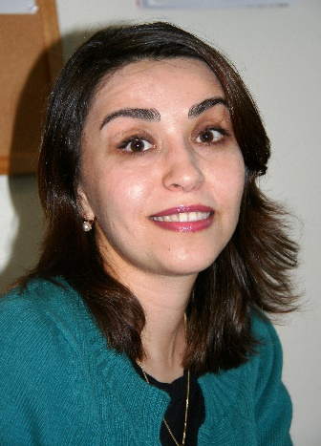
Rukhshona Kurbonova has been working in the field of public health for about 20 years, has higher medical education, experience in public service and public organizations (2000-2003). She has been working at IOM in the fields of migration, human trafficking, migrant health, gender and climate change since 2003. She is currently the Coordinator of the Migrant Health Programmes. Since 2005, she has been in charge of the Department of Migrant Health, where she has developed a number of innovative projects to prevent HIV and TB among migrants and their families, to build the capacity of the network of NGOs in the field of migrant health, to strengthen intersectoral cooperation, to implement a minimum package in the field of cross-border TB and HIV control, to involve diaspora organizations in prevention activities and health services for migrants, to develop a network of "peer-to-peer" migrants, and to strengthen the capacity of health professionals. Rukhshona Kurbonova is a member of the Migration, Health, Development, and Research Initiative (MHADRI) - Migration, Health, Development and Research Initiatives research network on migrant health.
Contact details: rqurbonova@iom.int
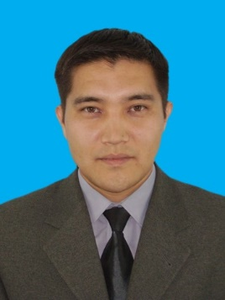
Ulan Soronkulov was born in Bishkek. In 2000, he went to serve in the Armed Forces of the Kyrgyz Republic. He then worked as a teacher at the Kyrgyz State University. Previously, he worked for the East-West AIDS Foundation as a trainer. He has extensive experience as a project coordinator. Recently, he joined the AIDS Foundation East-West Kyrgyzstan team as a program assistant.
Contact details: soronkulov@gmail.com

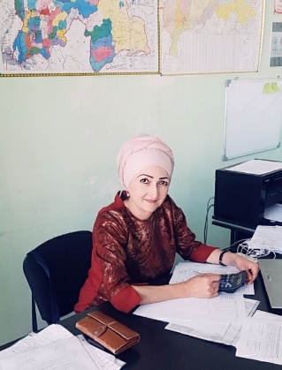
Zarrina Siyakova was born and raised in Dushanbe, Tajikistan. She is currently the coordinator at the Tajik Network of Women Living with HIV. She works on the Flagman project on HIV in Central Asia. She also provides jobs for women living with HIV in her studio. Zarrina helps people morally and spiritually. She supports women. She travels outside the country to participate at various Forums and to gain and share experience for further work in the field of HIV.
Contact details: siyakova.zarina.2016@gmail.com

